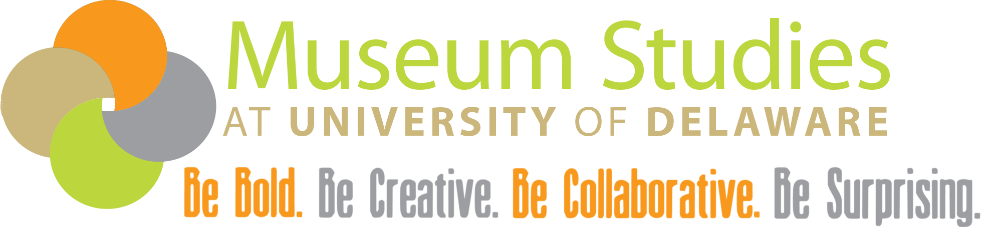

Minor in Museum Studies
Guide to Looking for Internships

Museum Studies Program, 77 E Main Street, Newark DE 19711 (302) 831-1251
Katherine Grier, Director kcgrier@udel.edu
Meg Hutchins, Program Coordinator mhutch@udel.edu

Finding an internship can seem really tricky but if you follow these steps it will make the process easy!

Identify your area of interest

Are you really interested in collections management? What about education or administration? Or are you just looking to learn a broad range of skills in museums? There are endless opportunities out there and figuring out what aspect of museums you are interested in will help you when looking for an internship.

Identify the site type you are interested in

There are a wide range of museum types. Some examples are science museum, art conservancy, historical society, national park, and historic house museum, just to name a few. Identifying what type of museum you would like to learn more about will help you narrow down your search.

Decide on your geographic search

Are you looking to do an internship while at home and so you need to find one out of Delaware? Do you need to stay here but are willing to travel around the Mid-Atlantic? Do you need something walkable from campus? Narrowing your search location can help but remember to not be too limiting. If you only want an internship in one town where there is only one small site they may not have any internship opportunities. Be specific but reasonable.

Set a meeting with Meg Hutchins, mhutch@udel.edu, 302-831-1251

As Program Coordinator, Meg is here to help you accomplish the minor and that includes helping find an internship. If you are not sure what you want to do or just how to search for internships she can get you started or give you some ideas of internships out there. It is also good to meet so that Meg can help set up the internship and get you started with the paperwork. It is also important to tell her about any funding or accommodations you would need from an internship site and when you are interested in completing the internship (summer, winter, or during a semester).

Look online for opportunities

Some organizations that have internships posted. They are listed below. MuseWeekly is the Museum Studies Program’s weekly jobs/internship e-newsletter which is also helpful. It is also helpful to start looking at the websites of museums or sites you are interested in.

AASLH: American Association of State and Local Histories http://www.aaslh.org/
AAM: American Alliance of Museums http://www.aam-us.org/
MuseWeekly https://www.museumstudies.udel.edu/museweekly/

Apply to or contact your sites of interest
Once you have found a few sites you are interested in, apply in the manner they have asked or contact them to find out what the application process is. Meg can help with this process.

Once you have an internship set up

Once you have something set up make sure to fill out all the needed paperwork for the minor and return what is needed to Meg. During the internship make sure to keep track of your hours so that you can get full credit.

If you have any questions do not hesitate to contact Meg Hutchins at mhutch@udel.edu or Dr. Grier at kcgrier@udel.edu.

