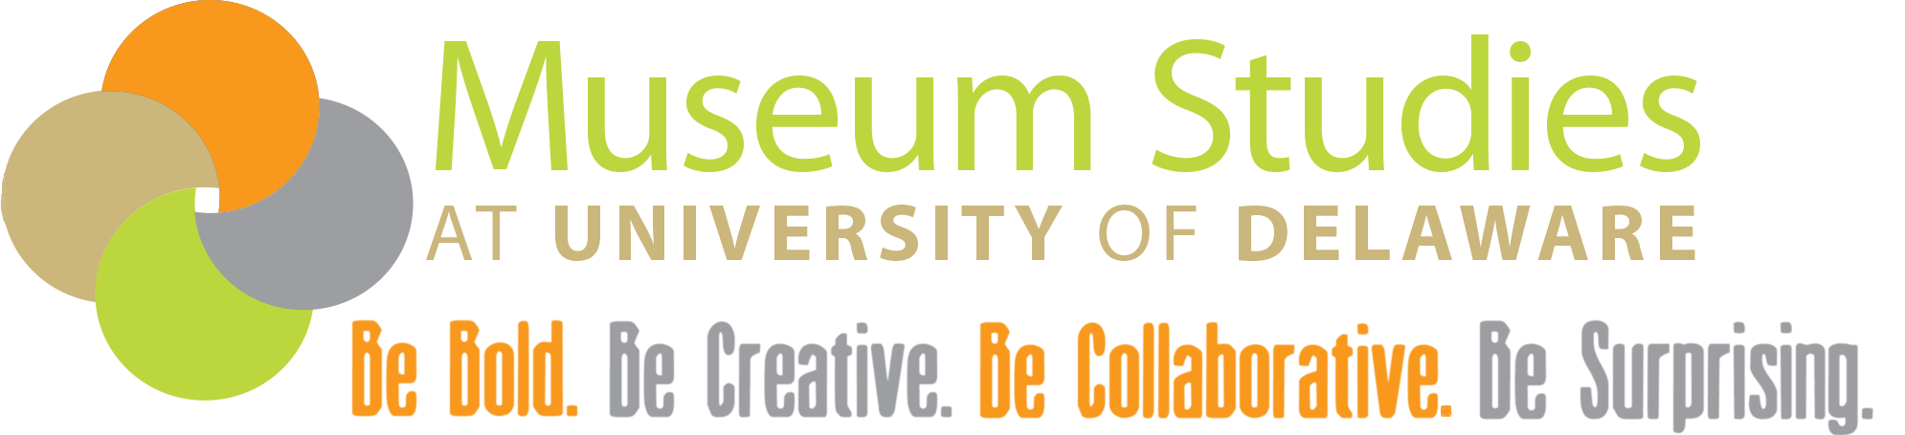

Certificate in Museum Studies - *Internship Agreement*

Museum Studies Program, 77 E Main Street, Newark DE 19711

Kenneth Cohen, Program Director [kcohen@udel.edu](mailto:kcohen@udel.edu)

Student Information

Name: _______________________________ Student ID: ____________________________

Expected Graduation Term: ____________ Email Address: _________________________

Telephone: ___________________________

Street Address: _____________________________________________________________________________

City/State/Zip: ______________________________________________________________________________

Emergency Contact

Name: _______________________________ Telephone: ______________________

Email Address: _______________________

Street Address: _____________________________________________________________________________

City/State/Zip: ______________________________________________________________________________

Institution Supervisor Information

Name: _______________________________ Title: ___________________________

Name of Institution: _________________________________________________________________________

Telephone: ___________________________ Email Address: _________________________

Street Address: _____________________________________________________________________________

City/State/Zip: ______________________________________________________________________________

Position Responsibilities

***Student Responsibilities***

1. Obtain information and forms for the internship application. Copies of any institutional information or forms should be uploaded with this form to your internship folder.
2. Meet with the Program Director to discuss plans for the internship.
3. **Meet with the institution supervisor to discuss plans for the internship - this should be done in-person if possible.**
4. Complete papers and projects assigned by the institution supervisor and Program Director.
5. Use the Internship Hours Log to document all internship hours and upload the completed log for the entire internship to your internship folder.
6. Upload all completed progress reports, final report, and site evaluation to your internship folder and email the Program Director that all documents are ready for review.

***Institution Supervisor Responsibilities***

1. Meet with the student to set a schedule and complete the Museum Studies Certificate Internship Agreement.
2. Provide meaningful work assignments related to the student's field of study.
3. Meet with the student frequently to discuss the progress of the internship.
4. Contact the Program Director with any concerns or issues.
5. Complete the job description, necessary progress reports, and final evaluation. Provide a copy of these reports and the evaluation to the Program Director and discuss contents with the director as required.

***Program Director Responsibilities- UD Representative***

1. Assist the student in completing Internship Agreement.
2. Set goals, dates, and evaluation methods for the internship with the student.
3. Assess progress reports and meet with the student during the internship to discuss the progress and assign additional requirements such as papers, projects, etc. This includes at least one site visit.
4. Assign credits and final grade for the internship.
5. Assist UD paid students with signing off in UDTime.

Internship Requirements

* Students must be enrolled in University of Delaware’s Museum Studies Program for the credits to count towards the certificate.
* Students must meet all requirements set by the host institution.
* Internships must be approved by the Museum Studies Program Director, and the hosting institution supervisor.
* An internship cannot take place at the site of the intern’s regular employment, or in a job in which the intern has been or is currently employed, unless given special permission.
* An internship will not be arranged and/or credit granted for previous work experience.
* Certificate students must complete **350 total internship hours**. These hours must be logged on the Internship Hours Log and uploaded to the internship folder by the end of the internship(s). *Note: Hours can be broken up into multiple internships with approval.*

***Reports***

* Depending on total hours worked for an internship, students may be assigned one or two 300-word progress reports describing the work completed and what the student has learned to date. These progress reports must be uploaded to the internship folder and the Program Director notified via email. See schedule section for more information.
* The Internship Site Evaluation Formshould be filled out by the student and Final Evaluation Form should be filled out by the institution supervisor. Both forms are online forms. If you need a paper copy, one can be requested from the Program Coordinator.
* Students will complete a final internship report that includes:
  + The name of their supervisor and the supervisor’s role.
  + Description of the institution they are interning that includes size, administrative structure, and mission.
  + Description of the work completed for the internship and how it fulfilled the internship’s educational goals.
  + The role the intern played within the larger project or site initiatives.
  + Discussion of the larger academic and educational facets of the work and project and how it furthered their academic studies.
* Copies of any work completed (or a representative sampling of) such as catalog records, bibliographies, exhibit materials, etc. should be submitted with the final report.
* The final report should be 8 to 10 pages in length formatted as follows: double spaced, 1-inch margins, 12-pt font, in Times New Roman.

***Other***

* Internships may be paid or unpaid. **Institutions are strongly encouraged to provide some financial support for students.** See compensation section for more information.
* All forms, logs, reports, and other items used in the evaluation process become part of the student’s permanent file in the program.
* Some students may be required to log hours in UDWorkforce. See compensation section for more information.

Job Description

To be completed by the Internship Supervisor.

*Student Job Title: ______________________________________________________________*

Description of Institution:

Description of Job/Project and Student Responsibilities:

Objectives and Educational Goals of Internship:

___________________________________________________________________________________________

Office Use Only

Dates Progress Reports, Evaluations, and Final Reports Due:

1st Report: ________________________ 2nd Report: ______________________

Site Evaluation: ____________________ Hours Log: _______________________

Final Evaluation: ___________________ Final Report/Essay: _______________

Schedule

Museum Studies Certificate students are required to complete 350 hours and the individual internship length will be agreed upon by the student and museum supervisor and approved by the Program Director. If an individual internship does not meet the required 350 hours, the student will be responsible for securing more than one internship to complete the required hours.

1. The internship will begin _______________ and end _______________.

MM/DD/YYYY MM/DD/YYYY

1. In general the intern will work _________ hours per day, _________ days per week.
2. The museum supervisor and the intern will meet _________ hours per week.
3. Probable weekly schedule ______________________________________________________.
4. The internship will be for ________ credit hour(s) and consist of _______ hours of work.

Compensation

Compensation for internship work is recommended but not required. If housing is part of compensation please include any leasing information that might be associated.

______________________________________ will be compensated ____________________ by

Student Name Amount

___________________________________ to fulfill the above internship hours. If the internship is

Institution

unable to be completed by the student or host site only a prorated portion of the __________ will have to be paid. Amount



Student will log hours via UDTime for payment.

_____________________________________ will provide housing for _________________________

Institution Student Name

at __________________________________________________________________________________

Address

from _______________________ to _____________________.

MM/DD/YYYY MM/DD/YYYY

Signatures

***Student***

I agree to carry out the terms of this internship. I will submit required evaluation materials on the dates set forward. I will discuss any changes in the goals or assessment measures that should occur during the term of the internship with the Internship Coordinator.

______________________________________ _______________________________________

Student Name Printed Student Signature

______________________________________

Date

***Institution Supervisor***

I agree to assist this student in fulfilling the work goals for my institution and in completing the stated learning objectives of this internship.

______________________________________ _______________________________________

Supervisor Name Printed Supervisor Signature

______________________________________

Date

***Museum Studies Program Director***

I agree to assist this student in fulfilling the work goals and in completing the stated learning objectives of this internship.

______________________________________ _______________________________________

Program Director Name Printed Program Director Signature

______________________________________

Date